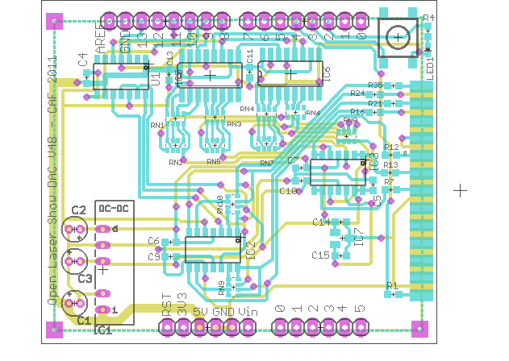
IC1 - 5V to +-12V DC to DC – 945-1105-ND – RB-0512D

Notes: None

C1, C2, C3 - 4.7 uF Electrolytic Capacitor 25V 20% – ECE-A1EKA4R7 – 4.7uF

Notes: Please pay attention to the polarity. All of the capacitors are not polarized in the same orientation on the board.

IC7 - 5.0V Voltage Reference – MAX6105EUR+TCT-ND – MAX6105EUR+T

Notes: None.

C5, C15 - 1.0 uF Capacitor 0603 – 445-1327-1-ND – 1.0 uF 0603

Notes: None.

LED1 - Green LED 0603 – 475-2709-1-ND

Notes: The orientation of the LED is important. Please orient the LED according to this drawing.
R1, R4 – 1k Resistor 0603 – P1.0KGCT-ND – 1k 0603

Notes: None.

S2 - SWITCH TACT MINI 6X6MM SMD – 450-1759-1-ND

Notes: None.

C6, C7, C9, C10, C11, C13, C14, C15- 0.1 uF Capacitor 0603 – 445-1326-1-ND – 0.1 uF 0603

Notes: None.

R7,R12,R13,R16,R21,R24,R35- 75R Resistor 0603 – P75GCT-ND

Notes: None.

RN9, RN10- RES ARRAY 10K OHM 4 RES 1206 1% (0603x4) – CRA6E810.0KACT-ND - CRA06E08310K0FTA

Notes: Please note that these are 1% resistor packs where as the ones used in the R2R color DACs are 5%. Do not mix them up.

RN2, RN5, RN7 - RES ARRAY 10K OHM 8TRM 4 RES SMD 5%(0603 x 4) – YC164J-10KTR-ND – YC164-JR-0710KL

Notes: None.

RN1, RN3, RN4, RN6, RN8 - RES ARRAY 20K OHM 8TRM 4 RES SMD 5% (0603 x 4) – YC164J-20KCT-ND - YC164-JR-0720KL

Notes: None.

U1 - 12 Bit Dual DAC Microchip - SPI - SOIC – MCP4922T-E/SLCT-ND – MCP4922

Notes: The dot on the board drawing represents pin 1 on the DAC.

IC5, IC6 - IC REGISTER SHIFT 8BIT 16-SOIC - 74VHC595M-ND – 74VHC595M

Notes: The dot on the board drawing represents pin 1 on the chip.

IC2, IC3 - Quad JFET OpAmp - SOIC Package – 497-3033-5-ND – TL084CD

Notes: The dot on the board drawing represents pin 1 on the chip. Pin 1 on the chip is represented by a flat edge and not by a dot.

U$1, U$2, U$3, U$4 - Shield Header - 1 x 36 Male Header Gold Plated .24" mating length – WM6536-ND

Notes: The single 36 pin header will have to be split into 2 x 8 sections and 2 x 6 sections. There will be a left over piece.

X1 – DB25 Female Solder Cup – L77SDB25S

Notes: The cups on the connector may have to be widened slightly using a screw driver or a scrap piece of circuit board. This connector is pressed on and then soldered. The top of the board is the top of the connector with pin 1.

